POSTER PRESENTATION KIT:
The WCTE 2025 Conference Committee welcomes you to participate in a Poster Presentation at the World Conference on Timber Engineering to be held in Brisbane, Australia, from Sunday the 22nd to Thursday the 26th of June 2025.
The Poster Presentation includes having your Poster on display in the foyer area of the conference for the duration of the conference, along with the opportunity to present a 4-minute presentation of your poster to the delegates in a scheduled slot during the last half of an allocated lunch break (maximum 2 slides for your presentation). The poster presentation requires the physical presence at the event of at least one of its authors.
If you do not want to present your poster, please advise the WCTE 2025 Conference Committee via email, so we can remove your presenting slot from the scheduled program. Email: wcte2025@civil.uq.edu.au
PLEASE NOTE: ALL accepted submissions (Oral and Poster) will be included in the conference proceedings and published in Proceedings.com, therefore each poster presentation is required to submit a full paper submission.
All downloadable documents will have a unique DOI (Digital Object Identifier) that provides all papers with a permanent web address. All papers will be indexed in Scopus.

Dates and deadlines:
Presenter registration deadline & Full paper submission due | 28 February 2025 (registration at early bird rates)  Please upload your Full Paper Abstract into the Speaker Management Portal using the template provided – see WCTE 2025 Abstract Management Kit for template.. You will receive an email, with instructions, when the portal is opened.
Early Bird Registration Fee | $1,400 AUD (inclusive of Welcome Reception, Gala Dinner & Closing Reception) - $1,250 AUD for Students

WHAT TO BRING:
Authors are required to bring:
- An A1 printed poster to be displayed on a poster board at the conference venue (Please refer to Style Guide for how to present your poster, included within this kit). All Authors must bring their own poster, there will be no printing facilities at the venue.
- A USB for the presentation which includes a maximum of 2 slides.
If you do not want to present your poster, please advise the WCTE 2025 Conference Committee via email, so we can remove your presenting slot from the scheduled program. Email: wcte2025@civil.uq.edu.au
Please note: Due to the number of people presenting on the day, there is a strict 4-minute presentation time limit.

Submission requirements:
- All posters are to be written in English using the Style Guide provided. If English is your second language, please ensure that posters are proofread prior to printing.
- Submissions should be original work.
- Submissions should be carefully checked for spelling and grammar.
- On acceptance, a full abstract submission will be requested – see full paper template. This will be published in Proceedings.com.
- Full Paper submission is due by 28 February 2025.

Style Guide- How to create a print ready poster:

These guidelines are intended to assist you to create your poster using Microsoft PowerPoint. The Poster is required to be Portrait A1 sizing and should contain a mixture of texts, graphs and images. Standard A1 size is 59.4cm x 84.1. The Poster should also include the WCTE 2025 logo on the top right corner of the poster.

Page Size and Orientation:
The First step is to open a single blank PowerPoint slide and set the page to A1. To do this:

- Click on the Design Tab and
- Click on the Slide Size icon and
- Select Custom Slide Size from the drop-down list. Type in appropriate width of 59.4cm and height 84.1cm.
Note: All Posters must be in Portrait

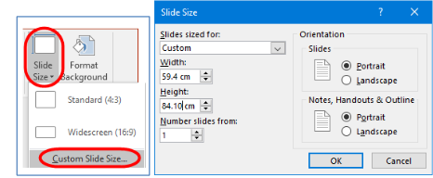

Background Colour:
If you want to use a background colour for your poster, use the Format Background option on the Design tab
then choose the appropriate background style. Remember the background colour is not the highlight of your
poster.

Text Boxes:
Use text boxes for key elements of a poster. PowerPoint has a range of option for how to creation, population and presentation your text.
To insert text boxes, click on the Insert tab and click on the Text Box icon in the Text group. If you need
to modify, resize or re-position a text box, you must first select it. Click on border of the text box to display the
selection handles. Resize the textbox as needed.

Images:
A poster without images, diagrams or graphs is unlikely to catch anyone’s attention and present as dull. Images can enhance your text and visually emphasize your key points.

Use of the WCTE 2025 Logo:
All posters should include the below WCTE Logo in the top right corner of the poster.



Resolution:
It is recommended that you use the highest resolution possible for your images, 150 dpi or higher. Do not use download graphics from the web, as they are only 72 dpi and generally will not reproduce well enough for your poster.

Guides and Gridlines:
PowerPoint has some useful tools to assist with Placement of items such as Text Boxes, Images and Graphs.
- The Guides tool displays two Guides -- one horizontal and one vertical and intersect at the centre of the slide. Dividing the slide into 4 sections. (Guides are not visible when you print.)
- Gridlines are square that appear and allow you to align shapes and other objects in your PowerPoint slide to distinguish between cell boundaries. They enable you to line up text boxes and images across the whole poster (Squares are not visible when you print.)

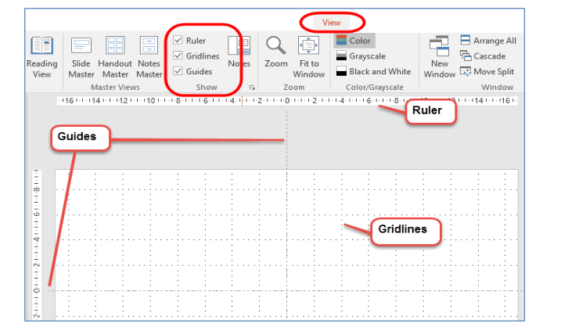

Font, Point Size and Line Spacing:
Remember that the poster will need to be read from 1 meter away, you need to ensure that the font point size is large for this.

As an example, for an A1 poster it is recommended:
- Normal text minimum 20-point
- Sub-headings between 40 to 50 points
- Main title should be 70 -80 points

Recommended fonts Arial, Times New Roman, Verdana, Garamond or Palatino with Arial and Verdana best for headings. For consistency use the same font throughout, use bold, italic, upper case and bullets for emphasis. Increasing the line spacing as this can also help to make text more readable. Use line spacing to help make text fit in a text box or the space you want it to.
Final Printing:
Your file must be sent to Printing as a PDF. To do this
1. Click on the File tab, then
2. Click on Save As,
3. Click on the Save as type down arrow and in the drop-down menu
4. Click on the PDF option

And lastly, don’t forget to bring your poster to the conference.

